**1 Oracle Non-Container Architecture**

**Oracle architecture is divided into 3 parts.**

1. **Memory structure**
2. **Process structure**
3. **Storage structure**

**Memory structure:**

* Memory elements in oracle database are **SGA** and **PGA.**
* SGA is shared global area.
* PGA is programmable global area or private global area.

**SGA:**

* SGA will starts when the instance is started.
* SGA is divide into 3 parts.

1. Shared pool. (again shared pool is divided into 2 parts)

* Library cache
* Data dictionary cache

1. Database buffer cache.
2. Redo log buffer cache.

* In addition to this we have **LARGE POOL**, **JAVA POOL** and **KEEP POOL**.

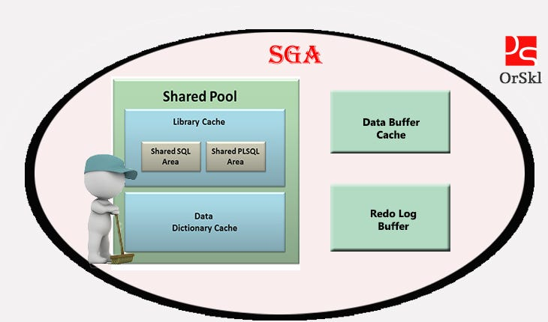

**Shared Pool:**

* It stores most recently executed SQL statements in the form of #values. That information is stored in library cache.
* It consists of two key performance-related memory structures.
* **Library cache** & **data dictionary cache**
* Sized by parameter **SHARED_POOL_SIZE**
* We can solve by flushing the shared pool.
* **ALTER SYSTEM FLUSH SHARED_POOL**;
* All the data in shared pool will gone.

**Library cache:**

* Stores information about the most recent used SQL and PL/SQL statements.
* This is managed by a least recent used (LRU) algorithm.
* This consists of two areas.
* Shared SQL area
* Shared PL/SQL area

**Data dictionary cache:**

* This contains metadata of each execution plan generated by optimizer. Which stored in library cache.
* It includes about database files, tables, indexes, columns, users, privileges and other database objects.

**Database Buffer Cache:**

* It stores copies of data blocks that have retrieved from the data files.
* Enables great performance when you obtain or update data.
* This is managed by a least recent used (LRU) algorithm.
* **DB_BLOCK_SIZE** determines primary block size.
* **DB_CACHE_SIZE** determines the size of **DBBC**.

**Redo log Buffer Cache:**

* It records all the changes made to the data blocks.
* Primary purpose is recovery.
* Changes recorded in **rlbc** are called redo entries.
* Redo entries contain information to reconstruct or redo changes.
* Size defined by **LOG_BUFFER**

**Keep Pool:**

* When user is executing same query more times. That query blocks are stored in KEEP pool.

**PGA:**

* PGA will start when the server process starts.
* For every server process there is a separate PGA.
* If the size of PGA is 100mb and 4 sessions are there each session will get 25mb.
* If the PGA size is not enough then database will use temporary tablespace.

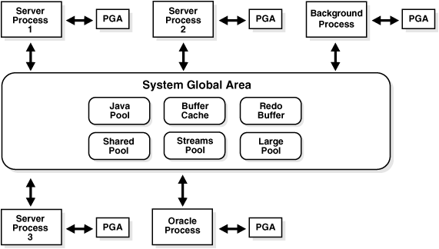

**Process structure:**

* This is having 2 types of background process.

1. **Mandatory background processes.**
2. **Non-mandatory background processes.**

**Mandatory background process:**

* These processes are must require to run the oracle database.
* If any of this Background process killed instance will terminated.
* Instance = memory + background process.

1. PMON (**Process Monitor)**
2. SMON (**System Monitor)**
3. RECO (**Recoverer**)
4. DBWR (**Database Block Writer)**
5. LGWR (**Log Writer)**
6. CKPT (**Checkpoint Process)**

**Non-mandatory background processes:**

1. ARCn (**Archiver process**)
2. CTWR (**Block change tracking**)
3. MMON (**Manageability monitor**)
4. MMAN (**Memory Manager**)
5. JOB QUEUE PROCESS

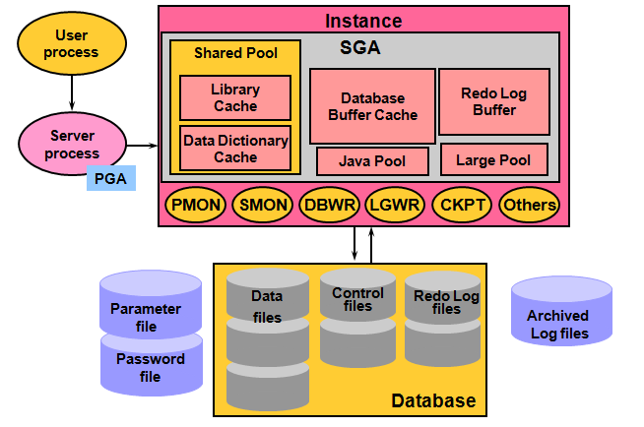

**User / Client Process**:

* A process that requests interaction with the oracle database.
* Cannot interact directly with the oracle database.

**Server Process:**

* **When user process start then there is a dedicated server process associated with that user process. It connects to the oracle instance when a user establishes a session.**
* **This server process can be dedicated or shared server.**
* **Server process reads required data blocks from data files on disk into the shared database buffers of SGA, if the blocks are not present in the SGA and returns results**

**Background Process:**

* **Started when an oracle instance is started.**

**Mandatory Background Process:**

**PMON**:

* If a user session disconnects unexpectedly, **PMON** roll back uncommitted transactions, and release if any locks, and free up memory.
* **PMON** monitor server processes and restarts them if needed.
* If there is any problem with redo log, then **PMON** will shut-down the database.
* In 11g PMON is responsible for registering db. entries into dynamic listener.
* In 12c LREG is responsible for registering db. entries into dynamic listener.

**SMON**:

* Whenever database got abnormal shutdown **SMON** will perform instance recovery in next start up.
* It will roll forward committed transactions & roll back uncommitted transactions.

**DBWR:**

* Initially modified blocks stores in database buffer cache. **Check** point will continually monitor dbbc and when dbbc got filled checkpoint will invoke **DBWR** process this will write modified blocks into actual datafiles.
* **DBWR** process writes dirty buffers to datafile under the following conditions.
* When the database issues checkpoint.
* When **server process** can’t find clean reusable buffer for new transactions.
* Every 3 seconds.
* Dbwr uses Least Recently Used algorithm LRU.
* Oracle provides multiple **DBWR** processes to share heavy data modification workload.
* You can have maximum of 20 dbwr processes.

**LGWR:**

* Lgwr writes the information available in REDOLOG BUFFER CACHE to actual redo log groups current redo.
* **CURRENT > ACTIVE > INACTIVE**
* If current redo got filled 100% then log switch will happen and if archive log mode is enabled. Then ARCHIVER process will generate physical archive.
* LGWR transfers content from RLBC to disk during the following conditions.
* Every 3 seconds.
* When redo log buffer filled up 1/3 of its size.
* When DBWR signal to LGWR to write.
* When commit occurs.
* Redo log buffer contains 1 mb of data.

**CKPT:**

* Ckpt is responsible for updating latest SCN to control file and data files headers.

**RECO:**

* RECO process is used for the distributed database configurations.
* Whenever any distributed transactions failed. This process will note down the failed transactions and once the network is established between distributed databases then this process will sync the transactions.

**Non-Mandatory Background Process:**

**ARCn:**

* This process is non-mandatory. We can enable or disable this process.
* If this process is enabled whatever the data which is available in redo log that is converted as physical archive by ARCHIVER process.
* If archive log is enabled whenever data loss occurs we can do recovery using archives.

**CTWR:**

* It is a change track writer.
* To increase the RMAN incremental backup speed we can enable **CTWR**.
* If this process is not enabled RMAN will read all the data files for modified blocks.

**MMON**:

* This process was introduced in oracle 10g.
* Mmon will take snap of the database for every 1 hour and stores in sysaux tablespace.

**MMAN:**

* This process was introduced in oracle 10g.

**ASMM (**AUTOMATICSHARED MEMORY MANAGEMENT**)**

* There is new parameter introduced from 10g that is **SGA_TARGET**.
* Instead of setting sizes for all the SGA components we can directly set size for this parameter.
* Before 10g we have to set sizes for all SGA components. (shared pool, dbbc, rlbc, large pool, java pool, keep pool)
* **MMAN** will dynamically resizes the SGA components whenever required.

**JOB QUEUE PROCESS:**

* This process helps to run the scheduled jobs.
* By default from 11g its value is 1000.
* We can disable this by setting value to 0 and no jobs will work.

**Storage structure:**

* Storage elements like different tablespaces, Permanent, Temporary, Undo.

1. **system**
2. **sysaux**
3. **users**
4. **Temporary**
5. **Undo**

**How select statement works:**

* When client process executed Select * from EMP; Syntax will check in client process itself.
* If the syntax is correct client process passes the query to server process.
* Server process will check symantic check(privileges)
* It will check weather user has privilege on the table. Table & Rows is present or not.
* If everything is fine this query is converted into machine level language and oracle generate number of execution plans. (execution plan= best way to get output)
* Optimizer will pick the best execution plan.
* Optimizer’s are two types.
* Cost based optimizer
* Rule based optimizer
* Once the execution plan is selected by the optimizer that plan is stored in LIBRARY CACHE as a # value and server process will do parsing.
* Now server process will check weather query related data blocks are present in DBBC or not.
* If data blocks are not available in dbbc then server process will pick the data blocks from datafiles to DBBC. (This is called hard parsing or cache miss)
* From DBBC to server process and to client process.
* Finally client will get result.

**Hard parsing**:

* If data blocks of query are not available in dbbc then server process will pick the data blocks from datafiles to DBBC this is called hard parsing or cache miss.

**Soft parsing**:

* If data blocks of query are available in DBBC this is called soft parsing or cache hit.

**How select statement works with sorting operations:**

* When client process executed Select * from EMP where no=1; Syntax will check in client process itself.
* If the syntax is correct client process passes the query to server process.
* Server process will check symantic check(privileges)
* It will check weather user has privilege on the table & Table & Rows is present or not.
* If everything is fine this query is converted into machine level language and oracle generate number of execution plans. (execution plan= best way to get output)
* Optimizer will pick the best execution plan.
* Once the execution plan is selected by the optimizer that plan is stored in LIBRARY CACHE as a # value and server process will do parsing.
* Now server process will pick data blocks from DBBC to PGA. Here for every server process there is associated PGA.
* In this PGA sorting operations will happen. If PGA size is not enough oracle will use’s temporary tablespace to perform sorting operation and gives output to the client.
* If temporary tablespace also not enough user will get **unable to extend temp tablespace** error.

**How update statement works:**

* When client process executed Update t1 set Sal=300 where no=1; Syntax will check in client process itself.
* Then select will happen and check block is available in datafile or not.
* If the syntax is correct client process passes the query to server process.
* Server process will check symantic check(privileges)
* It will check weather user has privilege on the table & Table & Rows is present or not.
* If everything is fine this query is converted into machine level language and oracle generate number of execution plans. (execution plan= best way to get output)
* Optimizer will pick best execution plan.
* Then server process will do parsing.
* Now server process will check weather query related data blocks are present in DBBC or not.
* If data blocks are not available in dbbc then server process will pick the data blocks from data files to DBBC and also to UNDO tablespace.
* Old value is stored in undo tablespace based on undo_retention policy.
* If user didn’t commit the transaction and undo_retention crossed user will get ORA-1555 error.

**Oracle Database Types:**

* **Enterprise Edition (EE)**: This is the most advanced version, designed for large-scale enterprises. It includes high-performance features like **Real Application Clusters (RAC)**, **Advanced Security**, **Partitioning**, and **Data Guard** for high availability.
* **Standard Edition (SE)**: A more cost-effective option for small to medium-sized businesses. It provides essential database functionalities but lacks advanced features like RAC and Partitioning.
* **Standard Edition One (SE1)**: This was an even more affordable version of SE, aimed at smaller businesses with basic database needs. However, Oracle has discontinued SE1, replacing it with **Standard Edition 2 (SE2)**.